PROGRESS REPORT KELOMPOK 3

HelpDesk

Selasa, 19 Febuari 2019

Anggota :

Muhamad Ilham Habibie

M. Iqbal Aula Rahman

Proggress :

1. Progress hari ini mengerjakan modul bagian Role, Quota dan Staff yang tadinya di pegang iqbal dan tambah modul Sub Category.
2. Transaksi masih dalam status on progress untuk L1 kurang assigment ke staff karena baru jadi modulnya, L2, dan L3 masih belum fix.
3. Login baru mau dibikin mas.
4. Acivity Diagram belum terevisi dari kelompok sebelumnya.

Modul :

|  |  |  |  |  |  |  |  |
| --- | --- | --- | --- | --- | --- | --- | --- |
| **Nama** | **Modul** | | | | | | |
| **Province** | **Regency** | **District** | **Village** | **Role** | **Religion** | **Quota** |
| Ilham | Done |  |  |  | Done |  | Done |
| Iqbal |  | Done | Done | Done |  | Done |  |
|  |  |  |  |  |  |  |  |
| **Nama** | **Modul** | | | | | |  |
| **Priority** | **Category** | **Ticket** | **Ticket Progress** | **Customer** | **Staff** |  |
| Ilham | Done | Done | Done | On Progress | Done | Done |  |
| Iqbal |  |  |  |  | Done | Done |  |

1. ERD

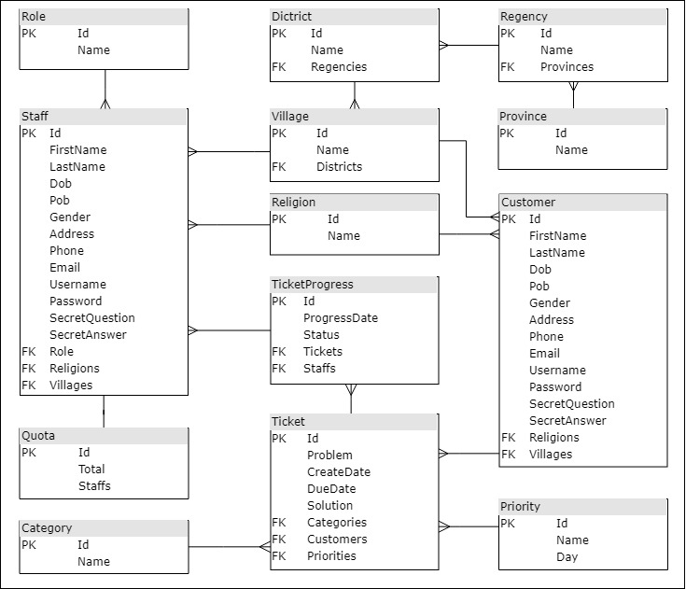

1. Use Case Diagram

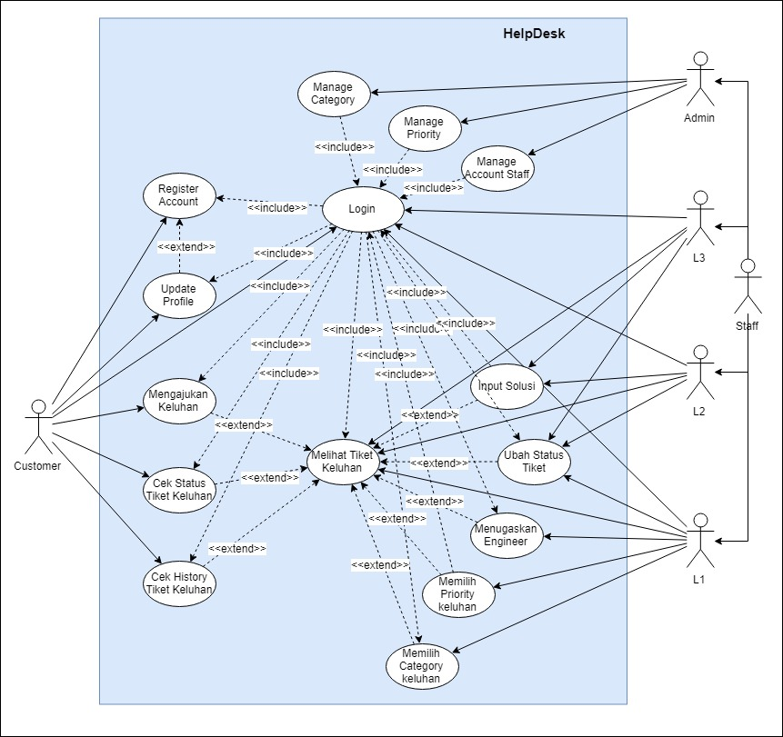

1. Class Diagram

